

**Green University of Bangladesh**

**Department of Computer Science and Engineering (CSE)**

**Faculty of Sciences and Engineering**

**Semester: (Spring, Year:2021), B.Sc. in CSE (Day)**

**LAB REPORT NO: 06**

**Course Title: Introduction to Decision making in C**

**Course Code: CSE 104, Section: D8**

**Lab Experiment Name: Introduction to Decision making in C**

**Student Details**

|  |  |  |
| --- | --- | --- |
| **Name** | | **ID** |
| **1.** | Jahidul Islam | 221002504 |
| **2.** |  |  |
| **3.** |  |  |

**Lab Date : 03/07/2022**

**Submission Date : 12/07/2022**

**Course Teacher’s Name : Mr. Mozdaher Abdul Quader**

**[For Teachers use only: Don’t Write Anything inside this box]**

|  |
| --- |
| **Lab Report Status**  **Marks: ………………………………… Signature:.....................**  **Comments:.............................................. Date:..............................** |

* **TITLE OF THE LAB EXPERIMENT**

1. Write a C program to find maximum between two numbers.
2. Write a C program to check whether a number is negative, positive or zero.
3. Write a C program to check whether a given number is odd or even.
4. Write a C program to check whether a number is divisible by 5 and 11 or not.
5. Write a C program to find maximum between three numbers.
6. Write a Program to take the value from the user as input any alphabet and check whether it is vowel or consonant (Using the switch statement).
7. Write a C program to check whether a year is leap year or not.

* **OBJECTIVES/AIM [1]**

1. To find maximum between two numbers.
2. Check whether a number is negative, positive or zero.
3. Check whether a given number is odd or even.
4. Check whether a number is divisible by 5 and 11 or not.
5. Find maximum between three numbers.
6. take the value from the user as input any alphabet and check whether it is vowel or consonant (Using the switch statement).
7. Check whether a year is leap year or not.

* **PROCEDURE / ANALYSIS / DESIGN [2]**

1. To find maximum between two numbers.

* Calculation: problem is solved using if – else loop.

1. Check whether a number is negative, positive or zero.

* Calculation: if – else ladder is used to solved it.

1. Check whether a given number is odd or even.
   * Calculation: Modulo division (%) by 2 == 0 for even number and Odd otherwise.
2. Check whether a number is divisible by 5 and 11 or not.
   * Calculation: Modulo division (%) by 5 == 0 for 5 and

Modulo division by 11 == 0 for 11 and is not otherwise.

1. Find maximum between three numbers.

* Calculation: to solved this problem we need to use loop within in loop.

1. take the value from the user as input any alphabet and check whether it is vowel or consonant.

* Using switch loop and 5+5 vowel for lowercase and uppercase letter, we can decide an character input is vowel and consonant otherwise.

1. Check whether a year is leap year or not.

* If we modulu divide year using 4 we will get whether it is leap year.
* **IMPLEMENTATION [2]**

I designed the programs in 5 section and separated them using multiline comment.

**TEST RESULT / OUTPUT [2]**

**Code 01:**

**1 #include <stdio.h>**

**2**

**3 int main()**

**4 {**

**5 /* program introduction */**

**6 printf("This program find maximum between two numbers.\n");**

**7 printf("It accepts integer value.\n");**

**8**

**9 /* required variables*/**

**10 int num1, num2;**

**11**

**12 /* required input */**

**13 printf("\nEnter the 1st number: ");**

**14 scanf("%d", &num1);**

**15 printf("\nEnter the 2nd number: ");**

**16 scanf("%d", &num2);**

**17**

**18 /* calculation */**

**19 if (num1 > num2){**

**20 printf("%d is Maximum.\n", num1);**

**21 }**

**22 else**

**23 printf("%d is Maximum", num2);**

**24**

**25**

**26 /* output section */**

**27**

**28 return 0;**

**29**

**30 }**

**Code 02:**

**1 #include <stdio.h>**

**2**

**3 int main()**

**4 {**

**5 /* program introduction */**

**6 printf("This program check whether a number is negative, positive or zero.\n");**

**7 printf("It accepts integer value.\n");**

**8**

**9 /* required variables*/**

**10 int number;**

**11**

**12 /* required input */**

**13 printf("\nEnter a number: ");**

**14 scanf("%d", &number);**

**15**

**16**

**17 /* calculation */**

**18**

**19 /* output section */**

**20**

**21 if(number > 0)**

**22 {**

**23 printf("Number is POSITIVE");**

**24 }**

**25 if(number < 0)**

**26 {**

**27 printf("Number is NEGATIVE");**

**28 }**

**29 if(number == 0)**

**30 {**

**31 printf("Number is ZERO");**

**32 }**

**33**

**34 return 0;**

**35**

**36 }**

**Code 03:**

**1 #include <stdio.h>**

**2**

**3 int main()**

**4 {**

**5 /* program introduction */**

**6 printf("This program check whether a given number is odd or even.\n");**

**7 printf("It accepts integer value.\n");**

**8**

**9 /* required variables*/**

**10 int number;**

**11**

**12 /* required input */**

**13 printf("\nEnter a number: ");**

**14 scanf("%d", &number);**

**15**

**16**

**17 /* calculation */**

**18**

**19 /* output section */**

**20**

**21 if(number % 2 ==0)**

**22 {**

**23 printf("Entered number is Even.\n");**

**24 }**

**25 else{**

**26 printf("Entered number is Odd.\n");**

**27 }**

**28 return 0;**

**29 }**

**Code 04:**

**1 #include <stdio.h>**

**2**

**3 int main()**

**4 {**

**5 /* program introduction */**

**6 printf("This program check whether a number is divisible by 5 and 11 or not.\n");**

**7 printf("It accepts integer value.\n");**

**8**

**9 /* required variables*/**

**10 int number;**

**11**

**12 /* required input */**

**13 printf("\nEnter a number: ");**

**14 scanf("%d", &number);**

**15**

**16**

**17 /* calculation */**

**18**

**19 /* output section */**

**20**

**21 if (number % 5 ==0)**

**22 {**

**23 printf("Entered number is Divisible by 5.\n");**

**24 }**

**25 else if (number % 11 ==0)**

**26 {**

**27 printf("Entered number is Divisible by 11.\n");**

**28 }**

**29 else{**

**30 printf("Entered number is not divisible.\n");**

**31 }**

**32 return 0;**

**33 }**

**Code 05:**

**1 #include <stdio.h>**

**2**

**3 int main()**

**4 {**

**5 /* program introduction */**

**6 printf("This program find maximum between three numbers.\n");**

**7 printf("It accepts integer value.\n");**

**8**

**9 /* required variables*/**

**10 int num1, num2, num3;**

**11**

**12 /* required input */**

**13 printf("\nEnter the 1st number: ");**

**14 scanf("%d", &num1);**

**15 printf("\nEnter the 2nd number: ");**

**16 scanf("%d", &num2);**

**17 printf("\nEnter the 3rd number: ");**

**18 scanf("%d", &num3);**

**19 /* calculation */**

**20 if (num1 > num2){**

**21**

**22 if( num1>num3)**

**23 {**

**24 printf("%d is Maximum.\n", num1);**

**25 }**

**26 else {**

**27 printf("%d is Maximum.\n", num3);**

**28 }**

**29 }**

**30 else if (num2> num3) {**

**31 printf("%d is Maximum", num2);**

**32 }**

**33 else {**

**34 printf("%d is Maximum", num3);**

**35 }**

**36**

**37 /* output section */**

**38**

**39 return 0;**

**40 }**

**Code 06:**

**1 #include <stdio.h>**

**2 #include <stdlib.h>**

**3**

**4**

**5 int main()**

**6 {**

**7 /* program introduction */**

**8 printf("This program take the value from the user as input any alphabet \nand check whether it is vowel or consonant.\n");**

**9 printf("It accepts integer value.\n");**

**10**

**11 /* required variables*/**

**12 char char1;**

**13**

**14 /* required input */**

**15 printf("\nEnter a Character: ");**

**16 scanf("%c", &char1);**

**17 /* calculation */**

**18 switch (char1)**

**19 {**

**20 case 'a':**

**21 case 'e':**

**22 case 'i':**

**23 case 'o':**

**24 case 'u':**

**25 case 'A':**

**26 case 'E':**

**27 case 'I':**

**28 case 'O':**

**29 case 'U':**

**30 printf("%c is a vowel. \n", char1);**

**31 break;**

**32 case 0x0A:**

**33 printf("Enter Key is pressed.\n");**

**34 break;**

**35 default:**

**36 printf("%c is a consonant.\n", char1);**

**37 break;**

**38 }**

**39**

**40 /* output section */**

**41**

**42 return 0;**

**43 }**

**Code 07:**

**1**

**2 #include <stdio.h>**

**3**

**4 int main()**

**5 {**

**6 /* program introduction */**

**7 printf("This program check whether a year is leap year or not.\n");**

**8 printf("It accepts integer value.\n");**

**9**

**10 /* required variables*/**

**11 int year;**

**12**

**13 /* required input */**

**14 printf("\nEnter 4 digit year: ");**

**15 scanf("%d", &year);**

**16**

**17**

**18 /* calculation */**

**19**

**20 /* output section */**

**21**

**22 if (year % 4 ==0)**

**23 {**

**24 printf("%d is Leap Year.\n", year);**

**25 }**

**26 else{**

**27 printf("%d is not a leap year.\n", year);**

**28 }**

**29 return 0;**

**30 }**

**Output 01:**

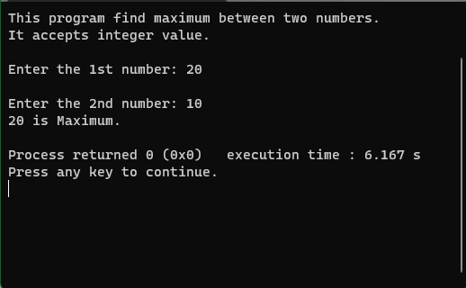

**Output 02:**

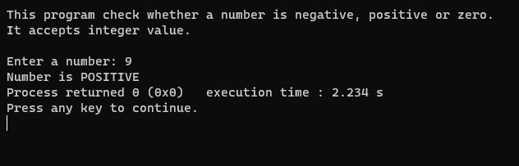

**Output 03:**

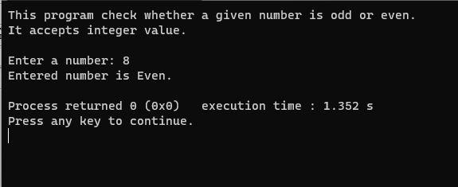

**Output 04:**

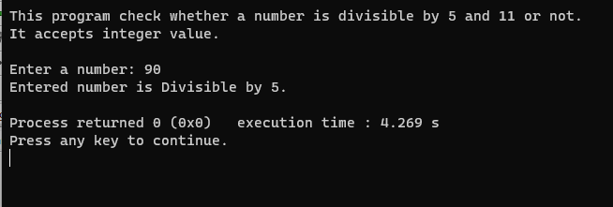

**Output 05:**

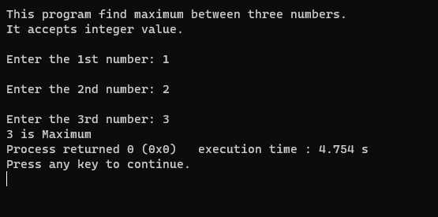

**Output 06:**

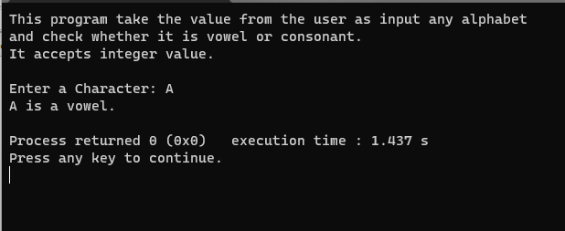

**Output 07:**

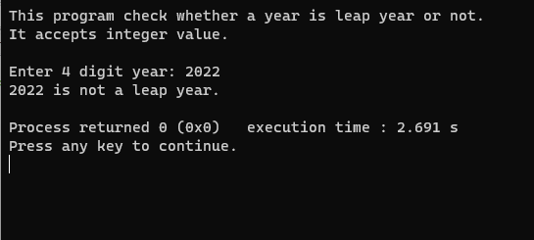

* **ANALYSIS AND DISCUSSION [2]**

These program outputs all the desired result correctly as asked in the manual. It runs well. The trouble spot of these problem is when and where to use the loop and whether it is if – else, else – if ladder, or switch.